**AP EXP-05**

**Q1. Maximum Depth of Binary Tree.**

**Code:**

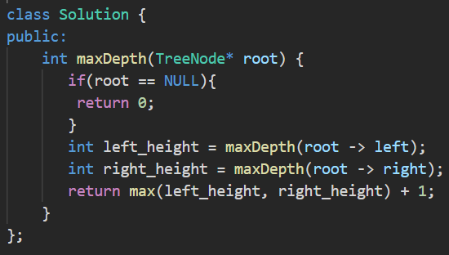

**Output:**

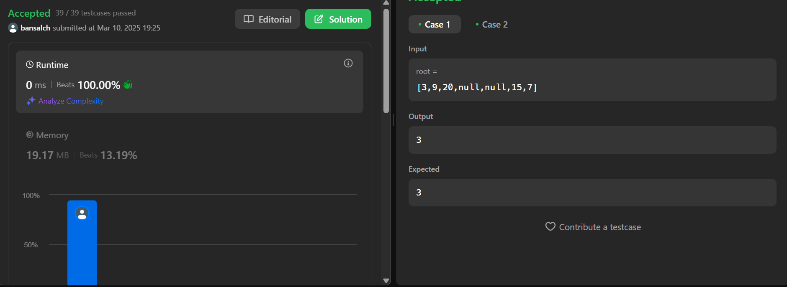

**Q2. Validate Binary Search Tree.**

**Code:**

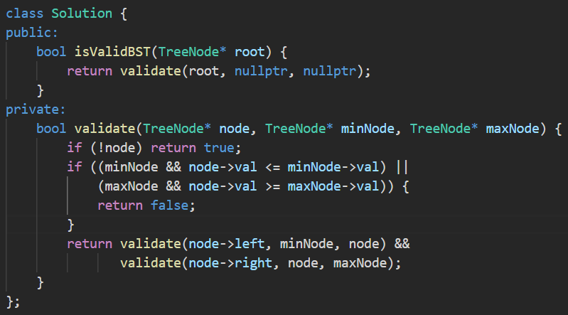

**Output:**

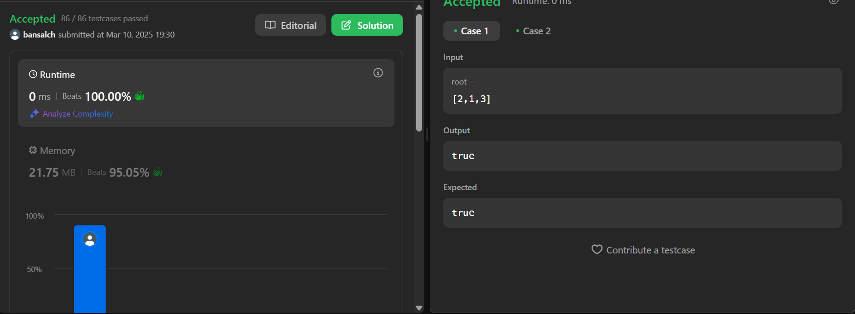

**Q3. Symmetric Tree.**

**Code:**

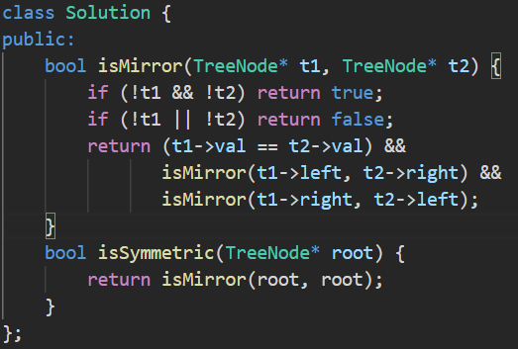

**Output:**

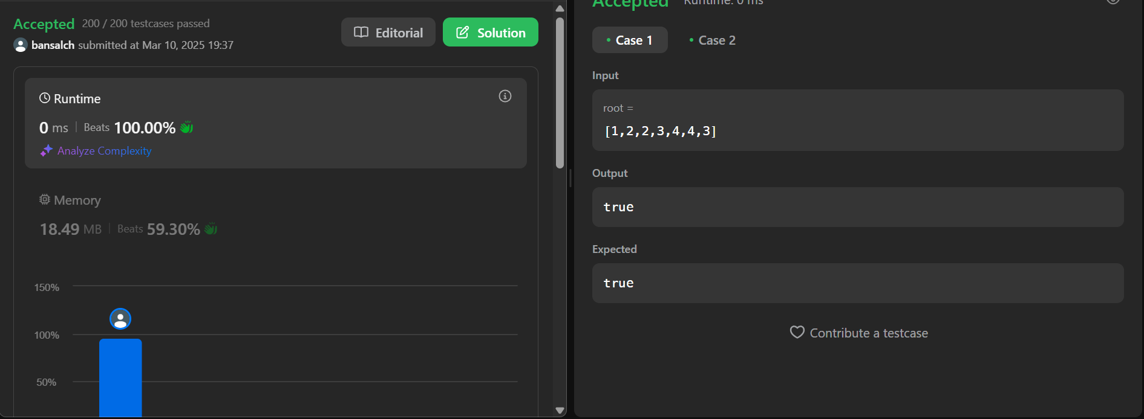

**Q4. Binary Tree Zigzag Level Order Traversal.**

**Code:**

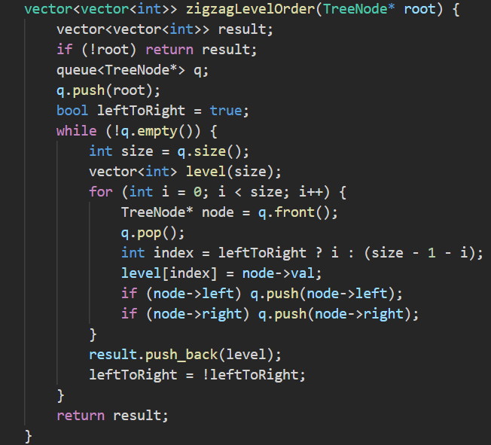

**Output:**

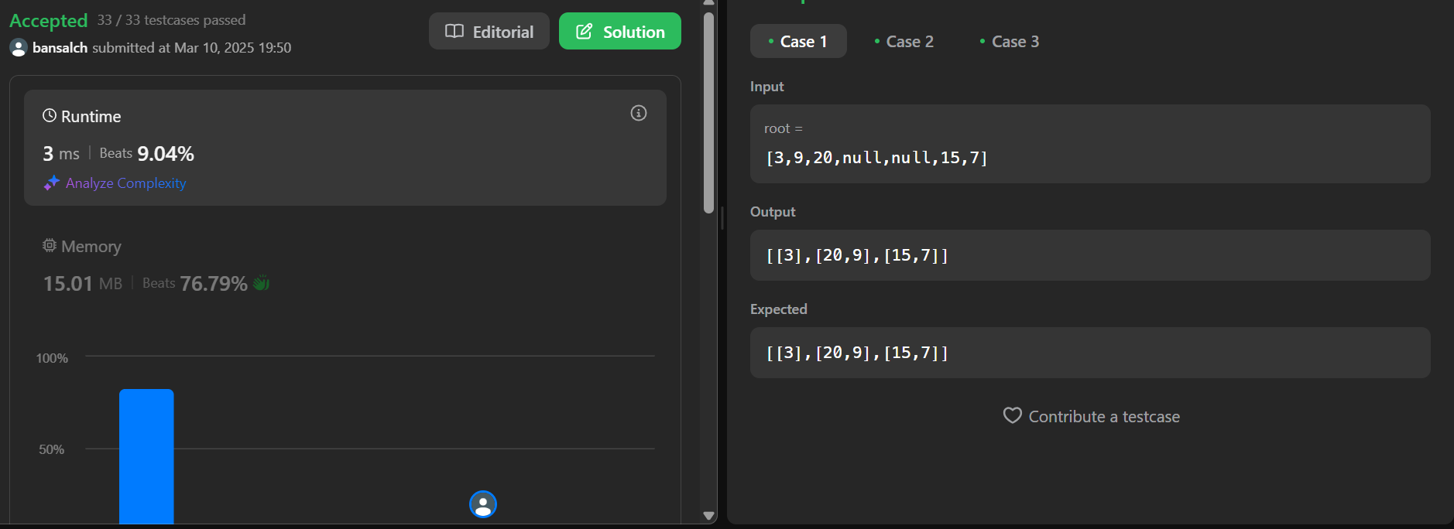

**Q5. Lowest Common Ancestor of a Binary Tree.**

**Code:**

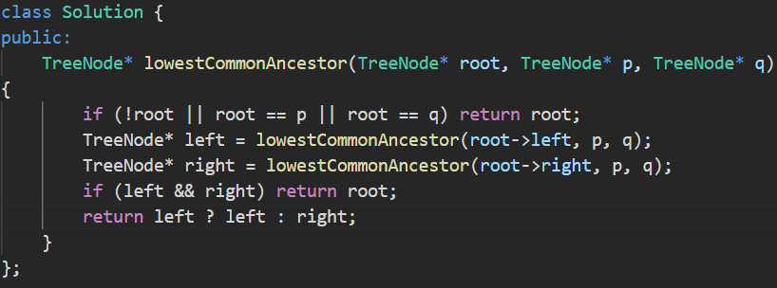

**Output:**

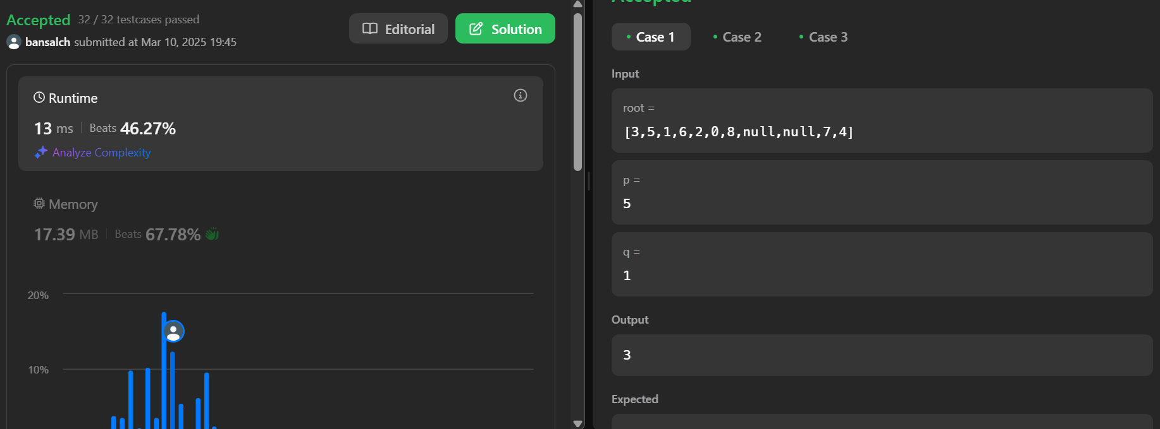

**Q6. Binary Tree Inorder Traversal**

**Code:**

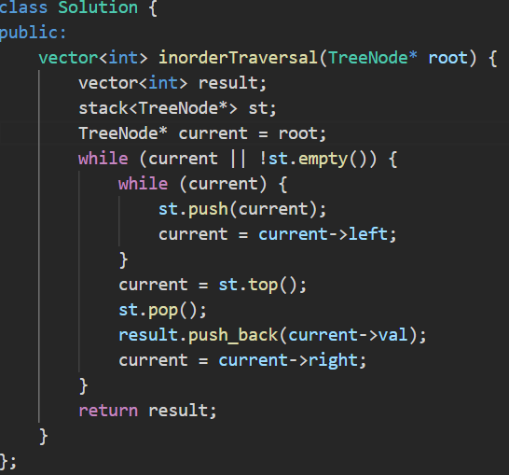

**Output:**

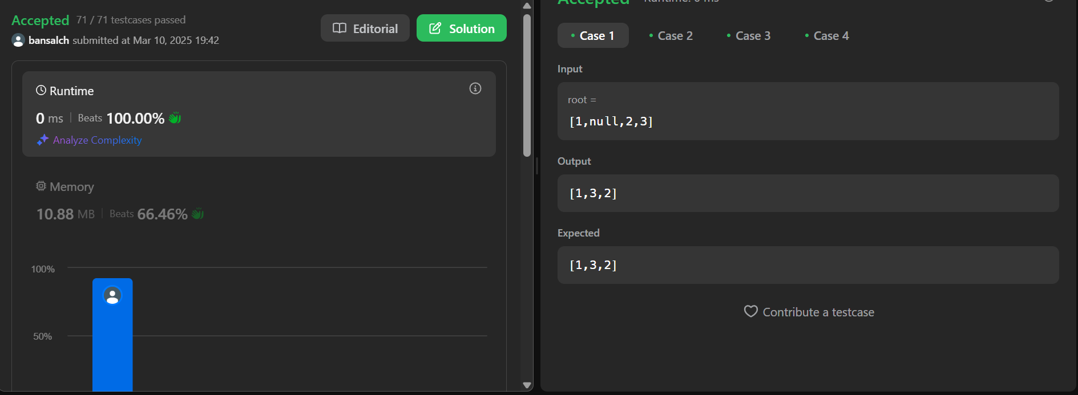

**Q7. Binary Tree Level Order Traversal**

**Code:**

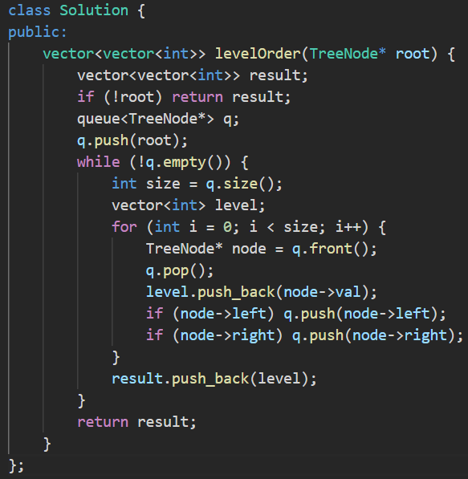

**Output:**

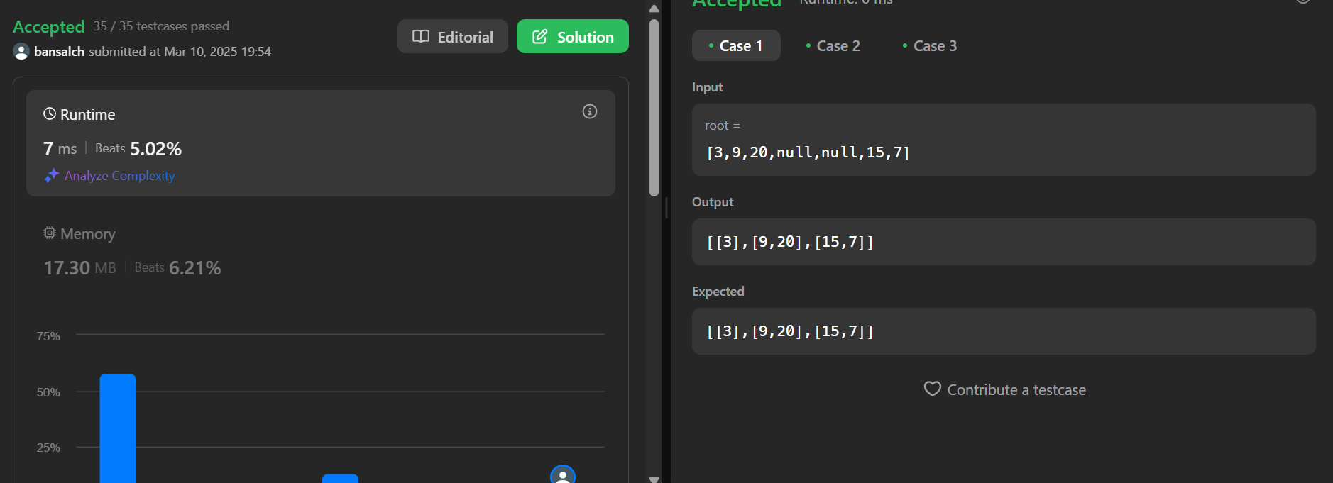

**Q8. Kth Smallest Element in a BST**

**Code:**

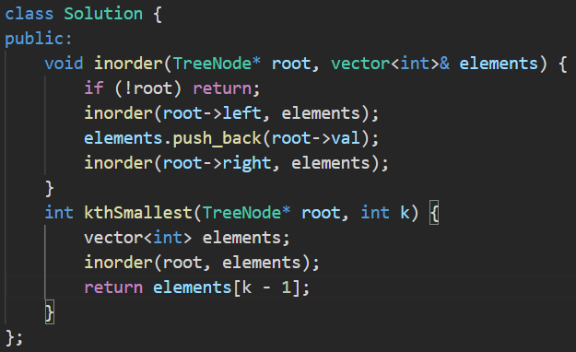

**Output:**

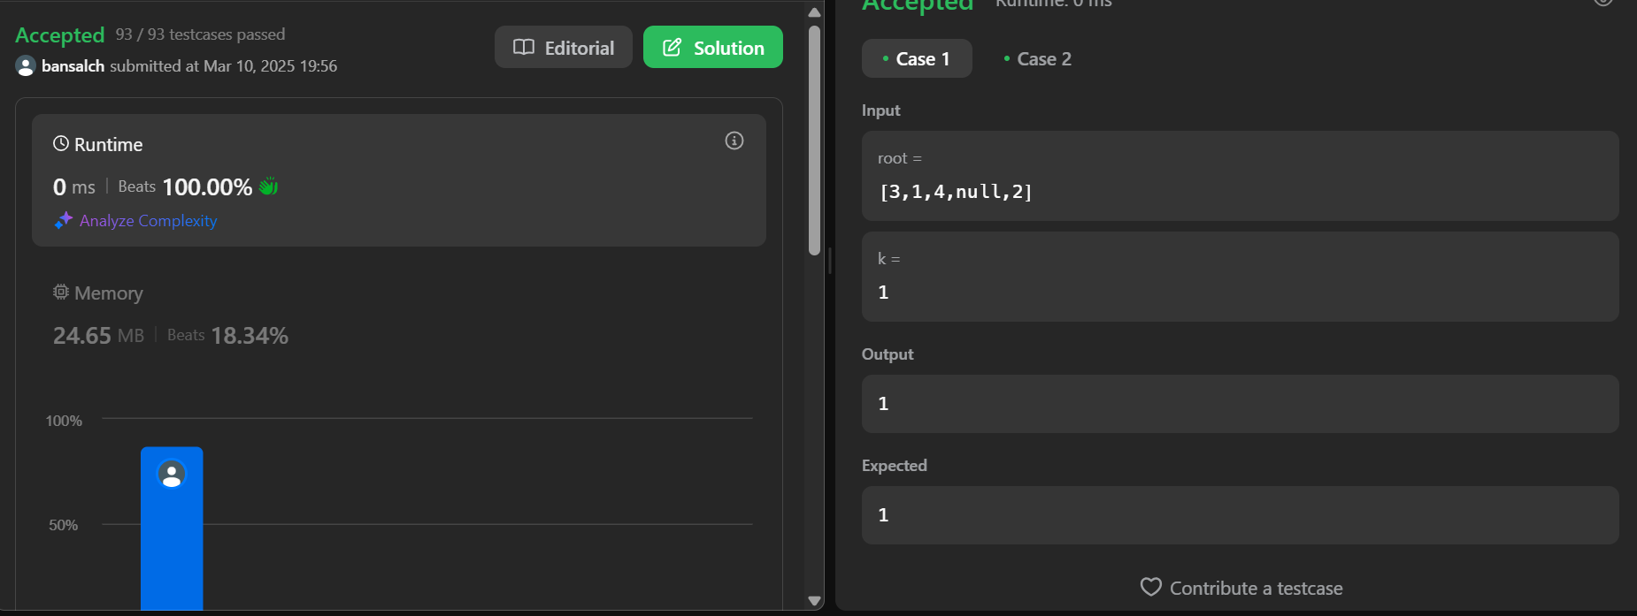

**Q9. Populating Next Right Pointers in Each Node**

**Code:**

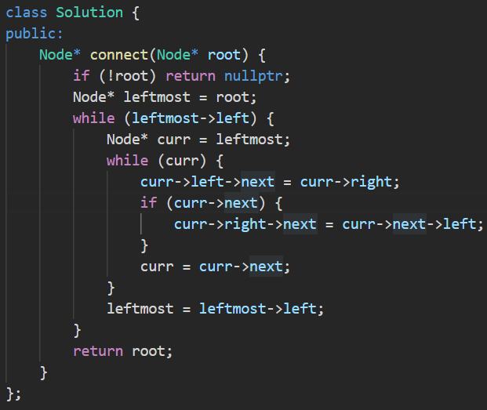

**Output:**

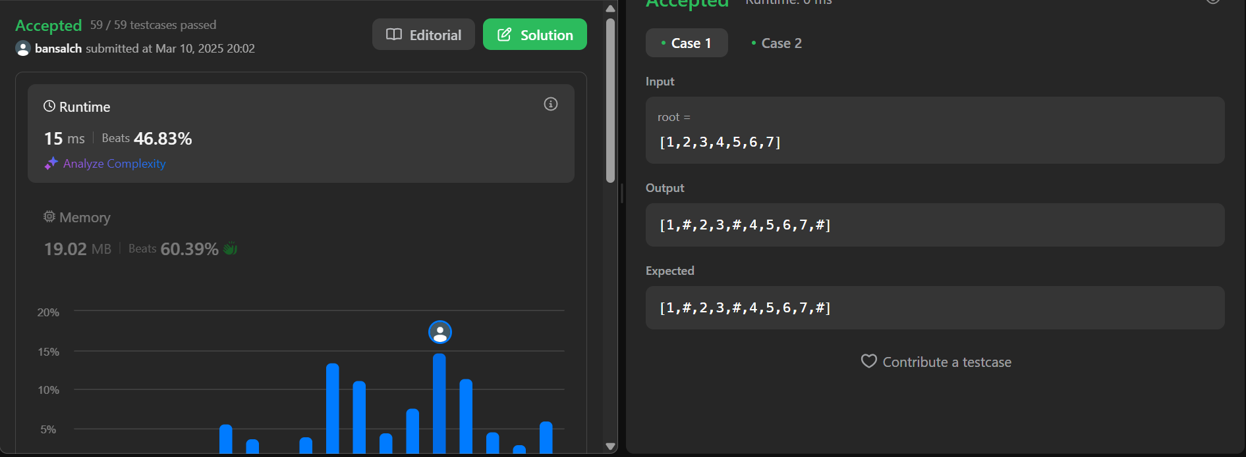

**Q10. Sum of Left Leaves**

**Code:**

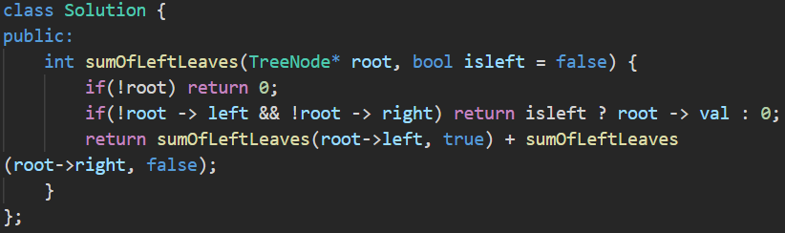

**Output:**

